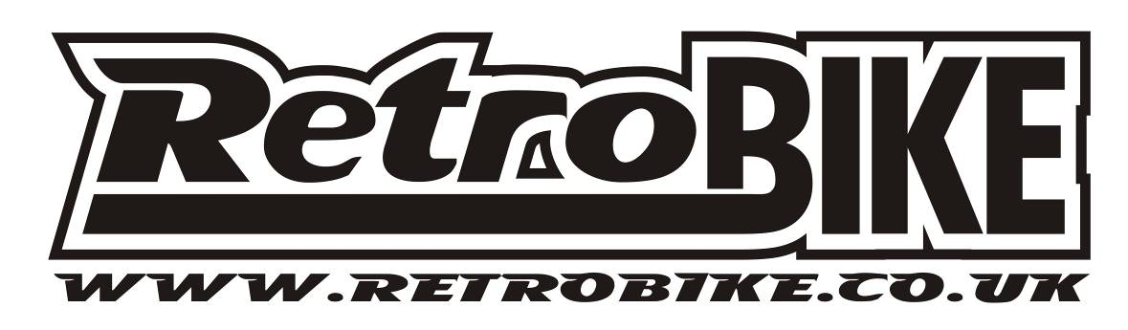
1993 Eddy Merckx Corsa Extra

year - make – model

Frame & Fork : 1993 Merckx Corsa Extra

Groupset : Mavic

Wheels : Mavic CXP30 on Mavic 501

Tyres : Veloflex

Stem : Cinelli

Handlebars : Cinelli Eubios

Seatpost : Shimano Dura Ace

Saddle : Selle Italia Flite Titanium

Extras :

Weight : 22 lbs
(approx)

